OpenAgileTM Learning SystemTM
Context Obstacles Assessment – Assessor's Guide

This assessment tool helps your organization to understand the context of a team and how that relates to potential obstacles and areas for improvement of team function. The assessment is conducted in two stages. First, detail the team's context, second, understand potential strategies and tactics for working effectively to change the context for the better. The results of this workshop are a number of obstacles added to the Obstacles Queue.

Running the workshop:

The OpenAgile Context Obstacles Assessment tool is designed to be used in a group workshop context. The Assessor will work with an appropriate group of people in an interactive fashion to collaboratively arrive at an understanding of the team's context and the strategies and tactics to use to improve that context. The workshop should generally take between one and two hours depending on the number of people in the group. The steps of running this workshop are as follows:
- Prepare the meeting space (see diagrams below):
  - Whiteboard or a flip-chart for drawing upon, and separately space for PostIt's arranged as follows...
  - Ten yellow 3x5 PostIt's arranged vertically at the left of the blank space with nothing written on them.
  - Five yellow 3x5 PostIt's arranged horizontally across the top of the space with the following labels: “SLA”, “Team Skills”, “Authority”, “Automate”, “Remove Waste”.
  - A large supply of orange 3x3 PostIt's.
- Introduce the purpose of the workshop: to understand the stakeholders and other groups that form the context of delivering value to end users / customers and to find opportunities for improvement in this context.
- The first part of the meeting should be limited to approximately 20-30 minutes. The second part for the remainder of the time.
- Part One: Context Diagram. (see the first diagram on the next page)
The Assessor draws a diagram with a medium-sized circle and the label “TEAM” inside of it. The Assessor asks the group to name various stakeholders and other groups that a team needs to work with. As each stakeholder or group is identified, the Assessor writes it up on the diagram in a small circle and connects it to the “TEAM” circle with a line. After the group has slowed down in identifying context, the Assessor can start to ask for information about the connection between the team and the other groups. The most important piece of information is the SLA – how long does it take when the team makes a request to get that request fulfilled. Additional information can be includes such as the name of a contact, or other notes. Once this diagram has stabilized, take a digital photo of it.
- Part Two: Improving the Context.
The Assessor now transcribes the various stakeholders and groups onto the yellow PostIt's that were arranged vertically. The Assessor then describes the principle that any work done outside the team in the process of delivering value to end users / customers should be considered an obstacle to be removed. Also describe the four strategies for removing these obstacles:
  - Expand the team's skills through training, growth or any other means.
  - Expand the team's authority so that they do not need external approvals to do work.
  - Automate something that was previously done manually to reduce the time it takes.
  - Remove wasteful activities altogether.
Now, the group decides what strategies would be appropriate to use to overcome each of the obstacles. The orange PostIt's are used to record the priority of strategies. For example, if the QA group is identified in the context, then the group participating in the assessment may decide that the first strategy to attempt is to expand the team's skills by including a member of the QA group on every team. The second strategy would be to automate much of the existing manual regression suite. The third strategy would be to increase the team's authority so that a separate group is not necessary to authorize release to production.
- The Assessor finishes the exercise by indicating that these strategies will be shared with those who are working on the implementation of agile methods.
The Assessor then fills in the values on the spreadsheet as an electronic record and records the names of the participants on the Tracking sheet. It is also recommended that a digital photo be taken of the resulting positioned PostIt's for distribution to participants. Once recorded, this information is shared with stakeholders to elicit feedback. This information is also used to help generate an initial list of Obstacles to deal with for the start of a project or projects.

The OpenAgile Project Success Assessment should be run at the start of every project (agile or otherwise) and roughly once a month as the project progresses.
Diagram: Context Obstacles Assessment – Context Diagram Sample:
TEAM
Usability
Product Mgmt.
QA
Release
Mgmt.
IT
2 days
5 days
4 hours
2 weeks
1 month
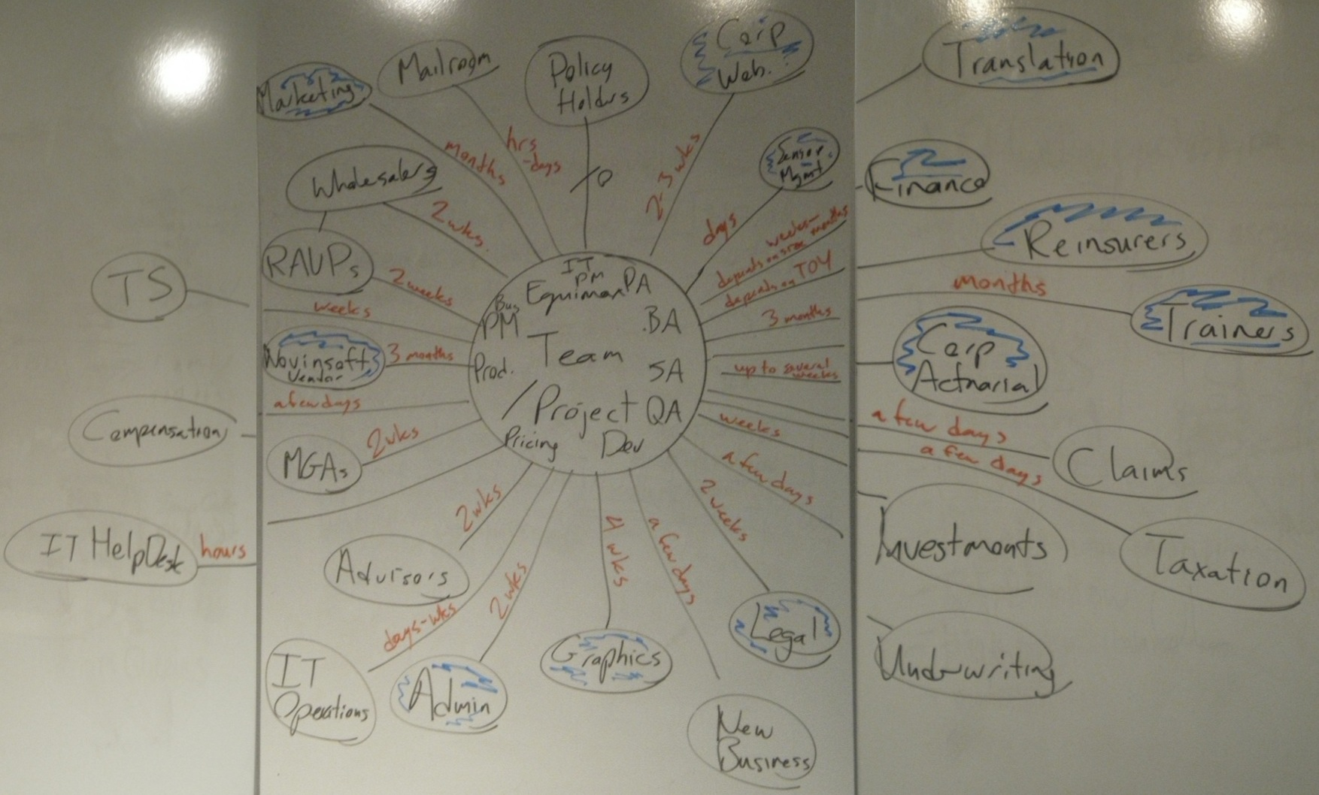
Diagram: Context Obstacles Assessment – Initial Arrangement:
IT
Prod Mgmt
QA
Rel. Mgmt
Usability
Authority
Automate
Waste
Skills
SLA

1

2

3

4

N/A

Diagram: Context Obstacles Assessment – Sample Final Arrangement:
IT
Prod Mgmt
QA
Rel. Mgmt
Usability
1
2
3
4
N/A
Skills
Authority
Automate
Waste
N/A
N/A
1
1
1
2
2
3
2
N/A
N/A
N/A
1
2
N/A
SLA
N/A
N/A
N/A
N/A
N/A

